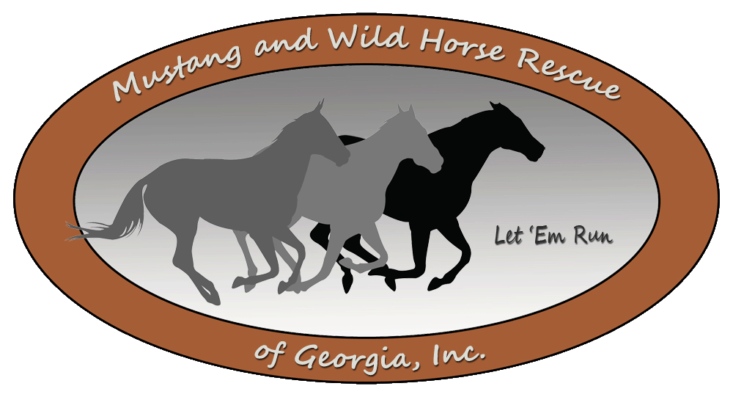
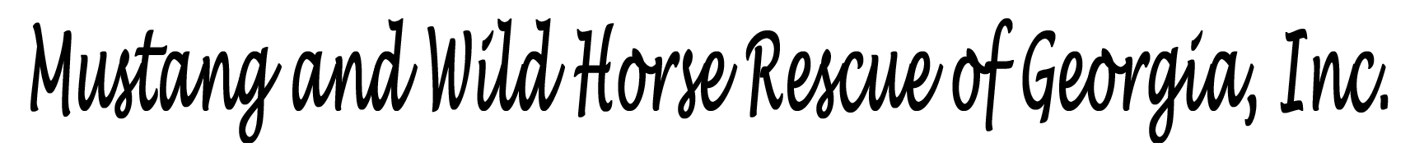

Adoption Process
So you are interested in adopting a mustang – Congratulations!

Serving the Southeast since 2002

What’s next?
The adoption process works like this:
- First, you need to request and then complete an adoption application. Contact the rescue by phone, the Contact Us page on our website or by e-mail to request an adoption application. Please note that MWHR only adopts horses out to Georgia residents or those that reside within 4 hours of our farm.
- Once your application is received and approved, Mustang and Wild Horse Rescue of Georgia, Inc. (MWHR) will contact you to schedule an appointment for you to come to our location and meet the horse you are interested in adopting.
- If you are what we consider to be a match to the horse, then we will arrange for a MWHR Area Coordinator to come to your location and do a home study. The home study is conducted at the location where you will board our horse. A home study is designed to evaluate and approve the facilities, ensuring that your place is safe and appropriate for a horse.
- Once your home study is completed and approved, you will then pay the non-refundable adoption fee, sign the contract and make arrangements to take the horse home. If needed, transportation for said horse can be arranged with MWHR at a rate of $1.75 per mile ($50.00 minimum). Adoption fees generally range anywhere from $150.00 to $500.00 plus. Please keep in mind that age, training and ride ability of the said horse plays a huge factor in determining the adoption fee.
- Once the horse is adopted from MWHR, the adopter agrees that the horse cannot be bred, sold, or given away. The adopter may not move the horse to a different location without first notifying MWHR and having the new location approved.
- MWHR will monitor you, your facility and your horse twice during the first year of adoption to check on the health and well-being of the horse. At the end of the first year, the adoption will become final. MWHR will sign the horse over to you with the understanding that if said horse does not work out for any reason - financial difficulty, sudden death of owner, etc. - the horse is to be returned to MWHR immediately.
- Please see our list of frequently asked questions (FAQ’s) below. If you have a question or concern that is not addressed, please contact us at mustangrescuega@gmail.com and we’ll be happy to help.

Thank you for your interest in adopting a MWHR horse
and for helping us find loving forever homes for America’s Living Legends!

Frequently Asked Questions
Does it cost money to adopt a horse?
Yes, our adoption fees generally range from $150 to $500+ per horse depending on age, training and ride- ability of the horse.
Where does the money go?
The adoption fee helps us to recoup a small portion of the investment that we have in the horse such as feed, vaccines, Coggins test, wormer, dental care, hoof care (farrier), gelding when needed, medical treatment, training, etc. Rescuing a horse can involve hundreds or even thousands of dollars. Prior to entering our program, many of our horses received little or no veterinary care or training. Consequently, it can get very expensive to provide adequate veterinarian and farrier care and tend to their other needs as well.
Can I adopt a horse, train it, and then sell it?
You are not allowed to breed, sell, or give away a MWHR horse. Our mission is to find loving “forever homes” for our horses.
Where do I go to see the horses and pick the one I want?
The MWHR farm is located in the Hickory Flat /Canton, GA area. However, at times our horses are housed in various foster homes in the Greater Atlanta area. We encourage you to contact MWHR with a description of the type of horse that you are interested in adopting so that we can help match you with an appropriate choice.
Can I meet the horse I want to adopt before I commit?
Absolutely! We would not expect you to adopt a horse without meeting or seeing the horse first. However, an appointment to meet an available horse is required and we do not release information about our farm location and/or foster homes until the adoption application is complete. This is for the safety and privacy of our horses and volunteers. Also, we want to ensure that the people who visit our horses are serious about adoption.
I want to adopt a horse, but I don’t have a horse trailer? Can MWHR deliver the horse?
MWHR can help make arrangements for transportation of your adopted horse. If transportation is arranged with MWHR, there is a transportation fee that is rated according to the number of miles travelled. This helps to offset our expense of gas, as well as to compensate for the time that it takes to haul the horse.
If I adopt a horse and then can’t keep it, what happens?
During the duration of the adopted horse’s life, if you change your mind or if your circumstances prevent you from keeping the horse, MWHR will take the horse back into our adoption program and re-home it into a forever loving home. However, your adoption fee is non-refundable. MWHR will make all the needed arrangements to transport the horse back to our facility unless the horse is outside a 50-mile radius of Canton, Georgia. If it is outside of this radius, it is the adopter’s responsibility to either arrange transportation back to our facility in Canton, GA or pay MWHR a transportation fee for hauling the horse back to our location.

What is MWHR looking for when they come to visit my home or boarding facility?
We are not looking for fancy; we are looking for safety, the ability to care for and provide adequately for the horse and give it love and attention. MWHR expects the horse to have a safe area for turnout and that it has adequate grass for grazing, hay or forage, shelter is available (if needed), and access to clean water at all times. We prefer board, electric tape or horse-wire fencing; not barbed-wire fence unless it is in excellent condition. We also look at the condition of any other animals on your property.
Why is MWHR so particular about who adopts a horse from them?
MWHR is selective because we have our horses’ best interests at heart; we love and care deeply about each individual horse. We have a lot invested in our horses, both financially and emotionally. We are not trying to “get rid” of our horses; we want to find them the best homes possible. By being thorough up front, we try to ensure that each horse is going to a wonderful, loving, forever home where it will be loved, and treated with the respect it deserves.

Thank you for your interest in adopting a MWHR horse
and for helping us find loving forever homes for America’s Living Legends!

